Date:

Student Name 1 & 2:Nguyễn Quang Tuấn Lộc & Lê Kỳ Vọng

**STRANGE INTERVIEW**

Pair up with a partner and test each other with these fun and challenging “job interview” questions. This one is all about lateral thinking and common-sense viewpoints. It’s also about active listening!

1. A man buys a new car and goes home to tell his wife. He goes the wrong way up a one-way street, nearly runs into 7 people, goes onto the sidewalk, and takes a shortcut through a park. A policeman sees all this and still doesn’t arrest him. Why not?

Just buy. He walk home

1. If you had a machine that could generate one million dollars a day, what would you be willing to pay for it?

Có rồi thì sao phải trả

1. Why is it against the law for a person living in New York to be buried in California?

Đang sống thì sao phải chôn

1. One house is made of red bricks, one of blue bricks, one of yellow bricks, and one of purple bricks. What is the green house made of?

Nhà kính làm bằng kính

1. A little girl kicks a soccer ball. It goes 10 feet and comes back to her. How is this possible?

Đá lên trời

1. In South Africa, you can’t take a picture of a man with a wooden leg. Why not?

Phải chụp bằng camera

1. You drive past a bus stop and see 3 people waiting for the bus: an old lady who is about to die, an old friend who saved your life, and your perfect partner. Knowing you can only have one passenger in your car, what would you do?

Đưa xe cho bạn trở người già. Mình đi với partner

1. How much dirt is there in a hole 3 feet deep, 6 feet long, and 4 feet wide?

No dirt

1. If it took 8 men 10 hours to build a wall, how long would it take 4 men to build the same wall?

No time

1. How far can you walk into the woods?

Nũa rừng. Qua là thành out

1. How many books can you put in an empty backpack?

1 cuốn vào thì hết empty

1. Your friend says he can predict the exact score of every football game before it begins. He's right every time. How is that possible?

0-0 trước trận đấu

**SKETCH THEM OUT**

Everything around you—cars, buildings, even our personal electronic devices—all started with an idea. This is an exercise in creative visualization. In the space below, sketch out an idea for an invention or a concept you think would be cool. Some ideas are provided, but feel free to come up with your own.

Suggestions

* *A portable source for charging a smartphone*
* *A traffic system that doesn’t rely on colors*
* *A machine that turns trash into energy*
* *A “green” vehicle*
* *An all-new method of personal transportation*
* *A new immersive gaming system*
* *An idea for a tablet or smartphone app*
* *A challenging and fun new idea for a sport*
* *A clever design for an interior space*
* *An idea for a social networking domain*

My Inventive Idea:

lồng diện diệt muỗi, đuổi chuột bằng sóng điện, xe đổi màu,

**FACT or OPINION**

This exercise is about differentiating between fact and opinion. A fact can be proven either true or false. An opinion is an expression of feeling or point-of-view and cannot be proven true or false. Consider some statements below to determine that they are either fact or opinion. If it’s a fact, write F and then briefly explain how it can be proven. If it’s an opinion, write O and briefly explain why you feel it can’t be proven.

1. It is a long way from Saigon to Hanoi. F

1. BMW’s are better cars than Fiat’s.: O

1. SaigonTech is a good university to research and study.: O -F

1. The lost city of Atlantis was a real city which disappeared under the sea.: O

1. Night follows day. F

1. It’s going to be a beautiful day tomorrow.: O

1. A Master degree is more difficult than a PhD degree.: O

1. I think that rock music is awful.: O

1. The legal age for drinking should be lowered to 16.: O

1. London is the best city in the world.: O

1. Today seems hotter than yesterday.: O

1. People worship God in churches.: F

1. The earth is round.: O

1. Summer follows spring.: F

1. The 2018 world cup will take place in Russia.: F

1. The British Winter of 2009/2010 was the coldest for 30 years.: F

1. You are studying at a University/College.: F

1. You are studying at a good University/College.: F

1. Your university/college is one of the best in Vietnam. O

**Triangle Challenge**

How many triangles can you find in this shape? Write your total in the space below.

There are ___13______ triangles.

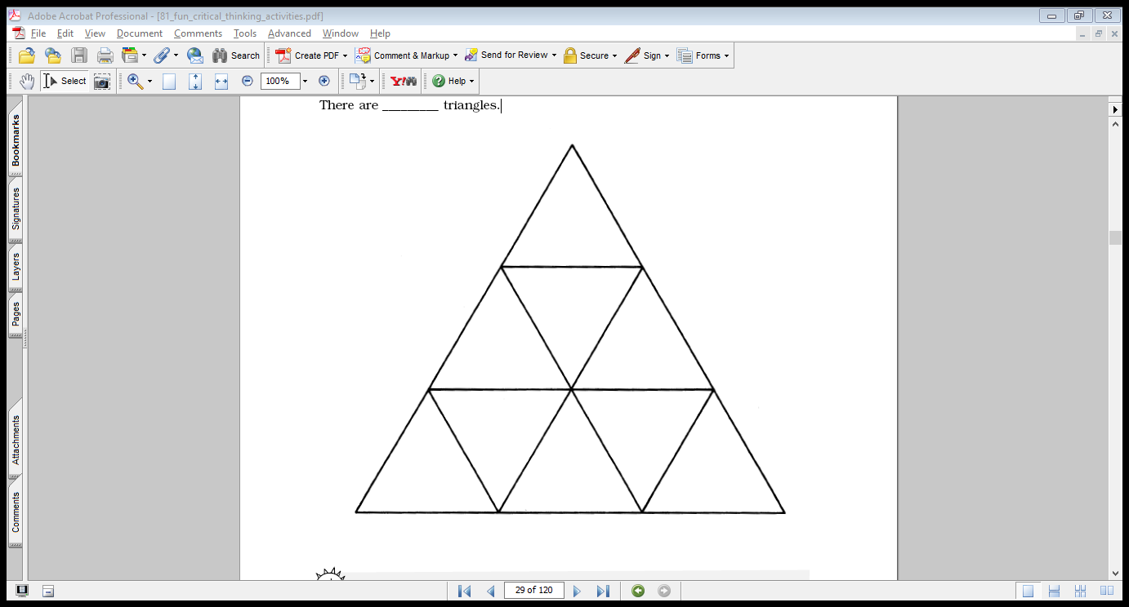

**How Do You Hide an Elephant?**

You probably can’t hide an elephant in your room, but you can hide one in a sentence. Let’s start small. Can you find the **goat** that is hiding in the sentence below?

*Lisa will go at dinner time.*

The two words **go at** spell goat when you put them together.

Now, find animals in the sentences below. Underline the letters that spell the animal names.

1. Go fish or see what we have to eat in the refrigerator.
2. Be artistic and paint a picture for me.
3. She needs a new cover for her book.
4. Tom iced the cake for the birthday party.
5. Do girls like soccer or baseball?
6. Ms. Dee read a book to the class.
7. What a big bowl of noodles you have!
8. Hop on your bicycle and let’s go for a ride.
9. Jess took a peek into the package.
10. “Slam bam!” the ball hit the rim with a crash!
11. Jay did kick it ten times in row. -
12. Please have dinner at my house on Monday.

**Anagram Adventure**

An anagram is a word that is made by rearranging the letters of another word. For example, here are four anagrams from the word post:

|  |
| --- |
| stop pots tops spot |

Can you form at least 3-4 anagrams from each of these words?

1. dare dear erad read eard
2. teas seat teas eats aset
3. meat team mate tame
4. pear reap pare prae rape
5. stale tales sealt satle
6. pans span naps snap
7. snail nails inals
8. acre care race
9. slap laps pals alps

**Magic Squares**

A magic square is an array of numbers arranged this way:

1. The square has the same number of rows and columns.
2. No number is used more than once.
3. The sum of every row, column, and diagonal is the same number.

Below are two magic squares that have been started for you. Complete each one by placing numbers between 1 and 9 in the squares so the sum of the rows and columns is 15.

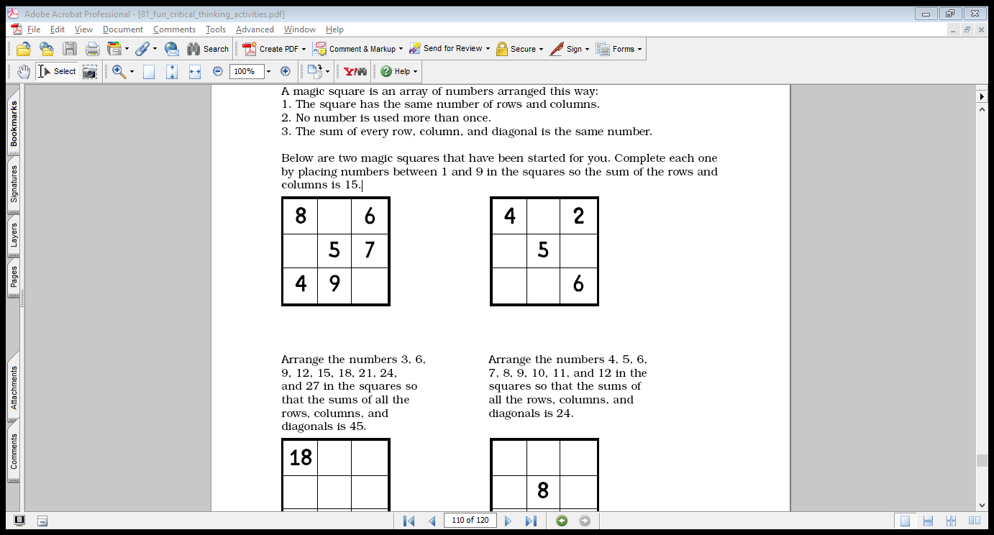

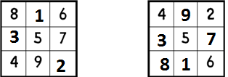

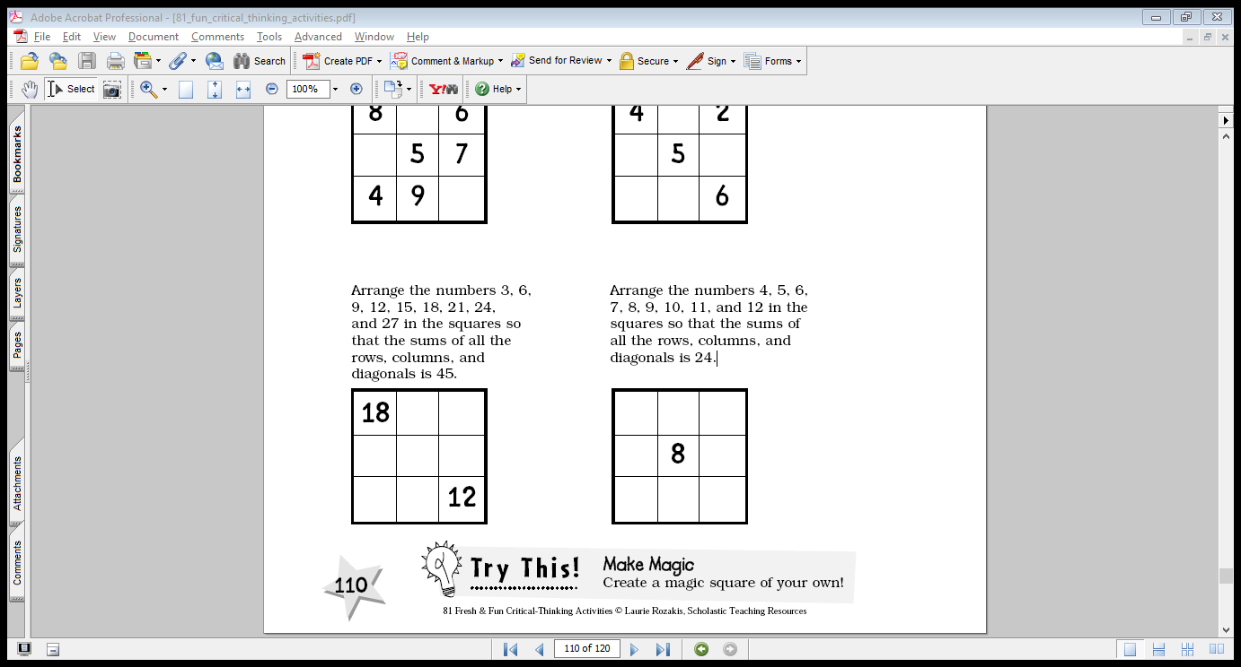Arrange the numbers 3, 6, 9, 12, 15, 18, 21, 24, and 27 in the squares so that the sums of all the columns, and diagonals is 45.

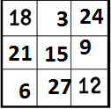

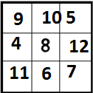

Arrange the numbers 4, 5, 6, 7, 8, 9, 10, 11, and 12 in the squares so that the sums of all the rows, columns, and diagonals is 24.